Nanyang Technological University

School Template

Site Administrator Training Guide

Table of Contents

1 Introduction 4

1.1 Objectives 4

1.2 Audience 4

2 SharePoint 2010 5

2.1 New Key Features in SharePoint 2010 5

2.2 School Template Layout 7

2.2.1 NTU Branding 9

2.2.2 Global Navigation & Navigation Menu 9

2.2.3 Home & Content Detail Page 9

2.3 Page Content Edit & Publish 10

2.3.1 Site Actions & Ribbon 10

2.3.2 Page Content Edit 11

2.3.3 Add a WebPart 12

2.3.4 Publish a Page 13

3 Content Creation and Edit 15

3.1 Create a New Site 15

3.2 Create a New Page 17

3.2.1 Content Page 17

3.2.2 Connector Page 18

3.2.3 Redirect Page 18

3.3 Setting up Navigation Menu 20

3.4 Rotating Banner(Slider) 21

3.5 Social Media Box 23

3.6 Print Friendly Button 24

3.7 Side Banner 24

3.8 News Webparts 26

3.8.1 NewsFilter & NewsList 26

3.8.2 NewsDetails 28

3.8.3 NewsSummary 28

3.9 Event Webparts 29

3.9.1 Event Filter & Event List 29

3.9.2 Event Details 31

# Introduction

## Objectives

This document will have the training materials to be used to train the site administrators of Nanyang Technological University (NTU) schools and colleges on how to familiarize the new template to meet their day to day operations.

## Audience

This document is intended for school or college site administrator, to walk through the new template layout design, and to learn how to maintain the page content and configure the new webparts.

The target audience and prerequisites for the course are as follows:

| **User Type** | **Qualifications** |
| --- | --- |
| End user/ Webmasters / Content Publishers | * Basic computer and internet operation skills * Must have knowledge in web usage |

# SharePoint 2010

The school website template is developed on SharePoint 2010. The new version offers a number of improvements over SharePoint 2007, including the user interface improvements, greater social capabilities, deeper business intelligence, advanced records and document management and better integration with other systems.

## New Key Features in SharePoint 2010

* ***New User Interface including Ribbon***
* Asynchronous user interface using AJAX and Silverlight (Built-in Support)
* **Site Actions** menu is moved to left side with the new options
* Ribbon interface brings SharePoint user experience much more consistent with other Office applications

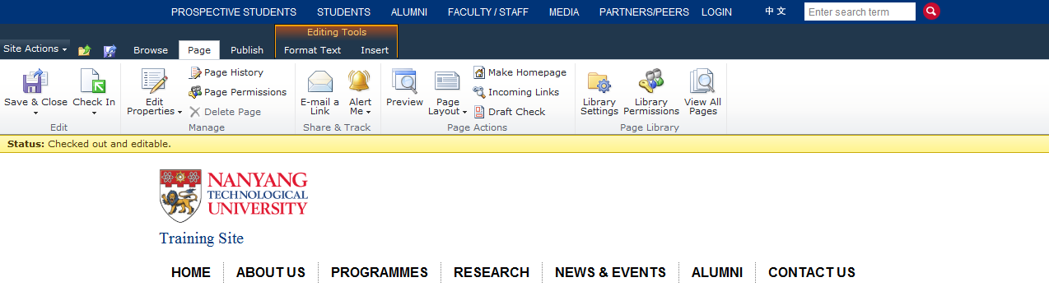

* ***Rich thin client functionality with many Office application***
* Easy to edit the rich text content on the page

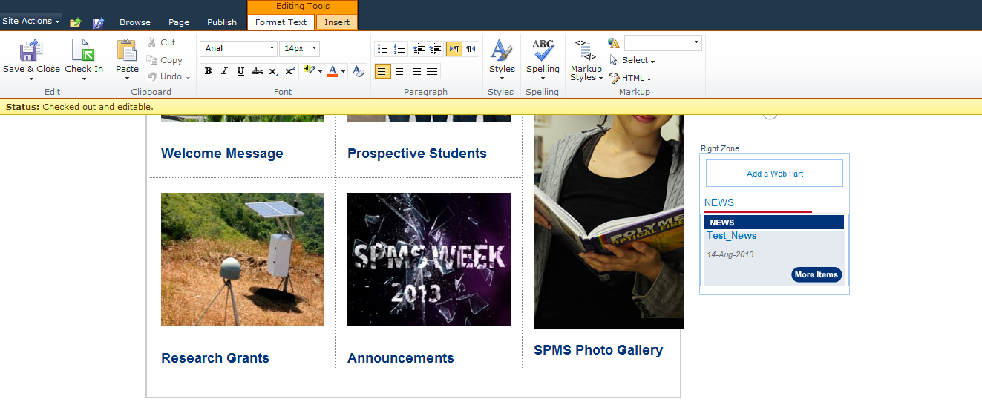

* ***New multiple document upload functionality***
* Simply to drag and drop the multiple files to upload in the document library.

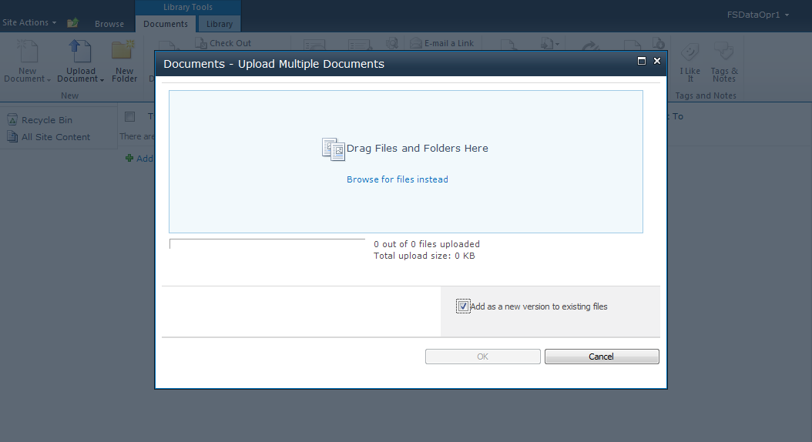

* ***Redesigned Central Administration web site***

Central Administration web site has been redesigned in SharePoint Server 2010 to provide a better user experience and make it easier for administrators to find what they are looking for.

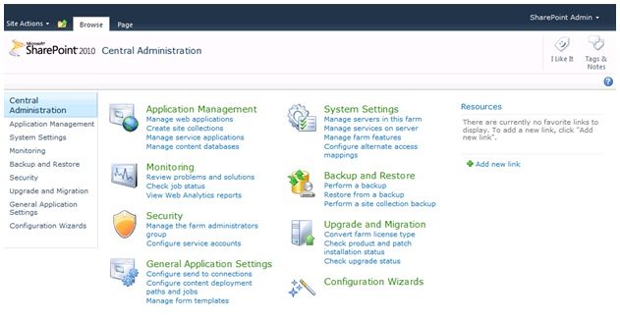

* ***New and enhanced SharePoint Designer 2010***

To work with SharePoint 2010, Microsoft has also introduced a new version of SharePoint Designer called as **SharePoint Designer 2010**.

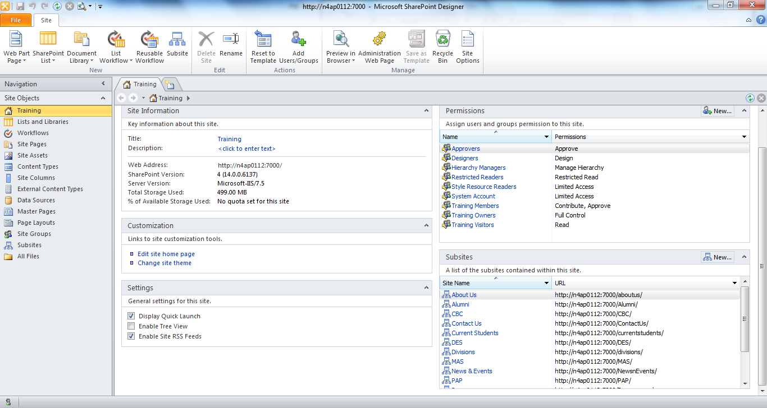

* ***Browser support matrix***

|  |  |  |  |
| --- | --- | --- | --- |
| Browser | Supported | Supported with limitations | Not supported |
| Internet Explorer 10 | 32-bit | 64-bit |  |
| Internet Explorer 9 | 32-bit | 64-bit |  |
| Internet Explorer 8 | 32-bit | 64-bit |  |
| Internet Explorer 7 | 32-bit | 64-bit |  |
| Internet Explorer 6 |  |  | X |
| Google Chrome (latest publically released version) | X |  |  |
| Mozilla Firefox (latest publically released version) | X |  |  |
| Apple Safari (latest publically released version) |  | X |  |

## School Template Layout

The new site template home page is shown as below and consists of the following areas:

* Header & Footer
* Navigation Menu
* Slider
* Content Area
* Social Media Box
* Print Friendly Button
* Side Banner
* Other content edit area (Webpart Zone)

Header

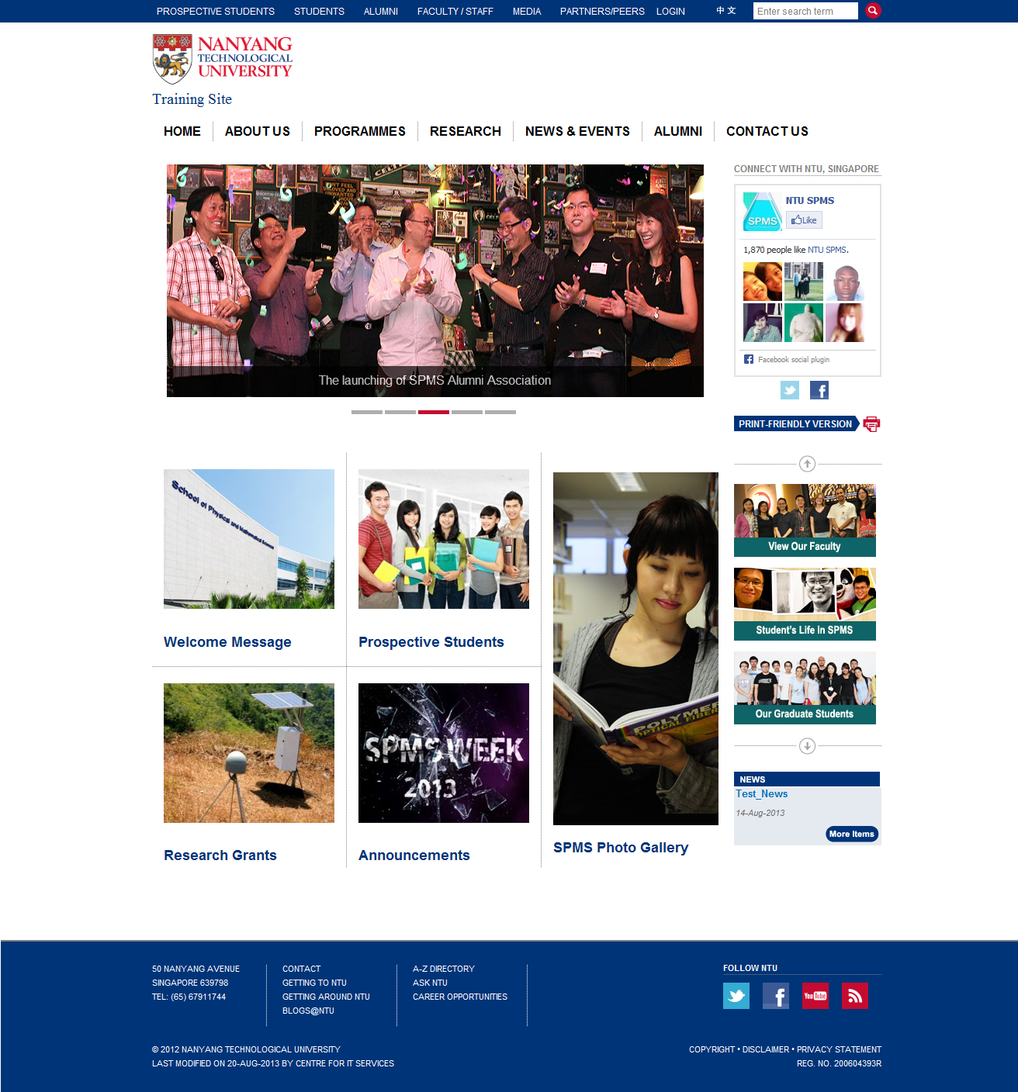

Other Content Edit Area

Content Area

Social Media Box

Side

Banner

Print Friendly Button

Slider

Navigation Menu

Footer

### NTU Branding

As a part of the visual NTU branding, no changes should be made on the site template design, layouts and global navigation.

### Global Navigation & Navigation Menu

The global navigation of School and research center site only support up to second level. The navigation menu in right side on detail page can be configured in Navigation of Site Settings.

### Home & Content Detail Page

Site owner can only edit the content and design within the following content areas by using the provided layout templates.

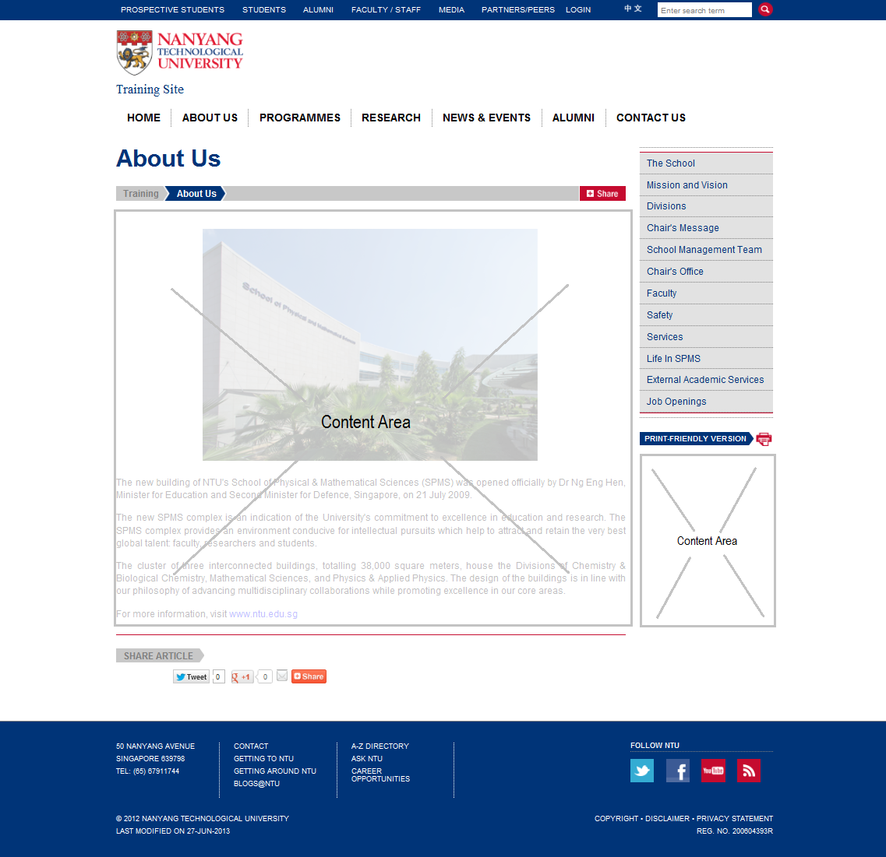

## Page Content Edit & Publish

### Site Actions & Ribbon

On top left corner, *Site Actions* link provides you with the basic functionality in managing a SharePoint 2010 publishing site, and the Ribbon bar will be shown in the page edit mode.

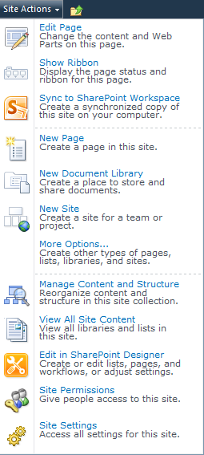

1. **Edit Page**

Click this menu to enter editing mode.

1. **Show Ribbon**

Click this menu to show the ribbon. The ribbon acts as a contextual menu. Its functions/buttons will differ based on the active control.

1. **New Page**

Click this menu to create a new page in the current site.

1. **New Document Library**

Click this menu to create a new document library in the current site.

1. **New Site**

Click this menu to create a new sub-site under the current site.

1. **Manage Content and Structure**

Click this menu to view site content and structure in tree view mode.

1. **View All Site Content**

Click this menu to view site content in list mode.

1. **Edit in SharePoint Designer**

Click this menu to edit the current page in SharePoint Designer.

1. **Site Permissions**

Click this menu to edit site permissions.

1. **Site Settings**

Click this menu to modify site settings.

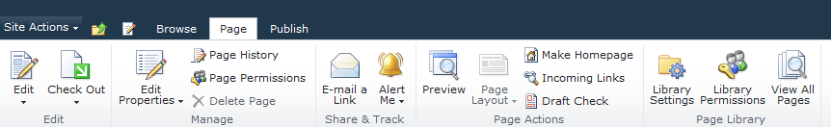

### Page Content Edit

1. To enter edit mode, click on **Site Actions** > **Edit Page**, or if the ribbon is shown, click on the ***Edit*** icon.

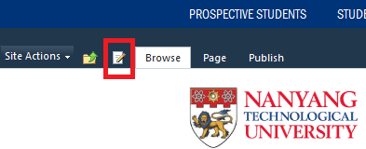

1. To add or edit content in a content placeholder, click on the ***Click here to add new content*** link on the placeholder.

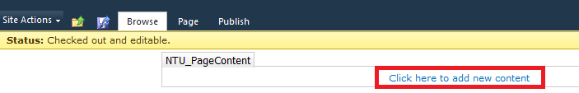

1. The content editing controls will be shown on the ribbon. To view and edit the HTML markup, click on the *HTML* button and then *Edit HTML Source*.

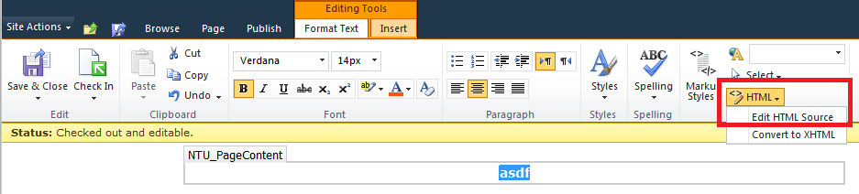

1. To save changes after editing a page, click on the ***Save*** icon or ***Page*** *>* ***Save & Close*** button.

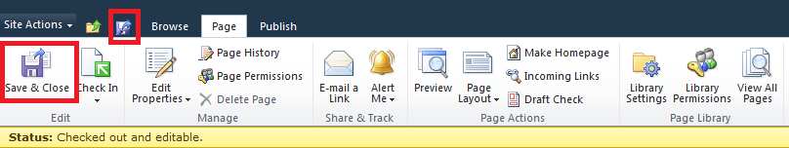

1. To exit edit mode without saving the changes, click on ***Page***, and then the small down arrow under ***Edit***, click on ***Stop Editing***. You will be prompted whether to save your changes, click on Cancel.

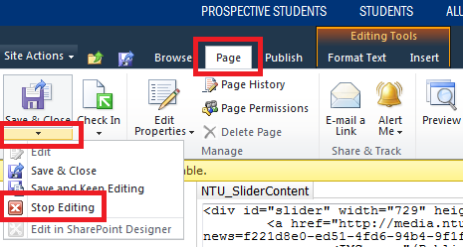

### Add a WebPart

1. To add a new webpart, click on the ***Add a Web Part*** link in webpart zone. Custom web parts for the school website are located under ***NTU Webparts*** category.

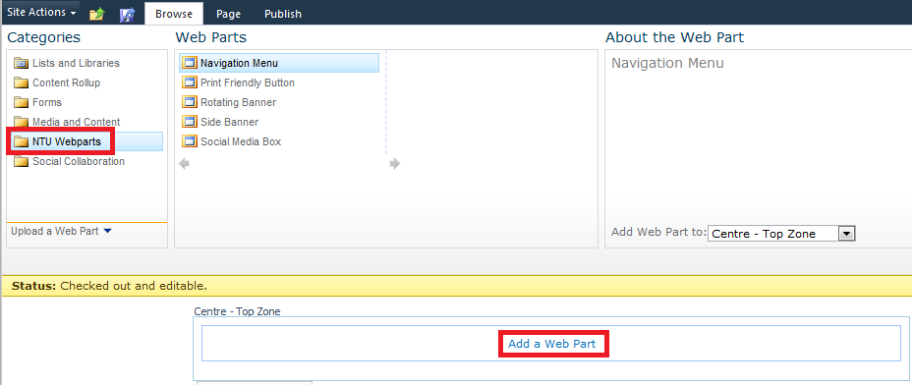

1. To edit the web part properties, click on the small arrow to the right of each web part and select Edit Web Part.

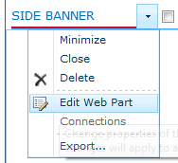

1. Scroll the page to the right to display the properties box.

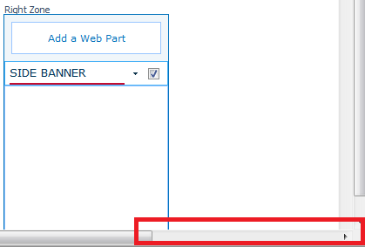

1. You can then make the changes to the properties. Custom properties are located under *NTU Properties*.

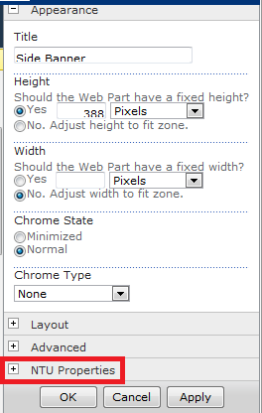

1. Click ***Apply*** to apply the changes without closing the properties box. Click ***OK*** to apply and close the box.

### Publish a Page

1. In ribbon bar, select the arrow button in **Check In** to choose the ***Check In*** or ***Discard Check Out*** in the drop down menu, which is located under ***Page*** tab.

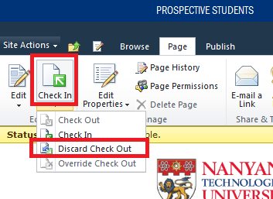

1. Click the **Publish** button which located under the ***Publish*** tab to publish the updated page.

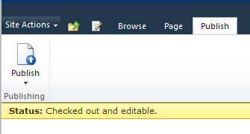

# Content Creation and Edit

## Create a New Site

1. To create a new sub-site, click on **Site Actions** > **New Site**.

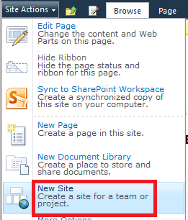

1. Click on ***Publishing*** on the left navigation, select ***NTU Site***, and type in the **Site Name** and   
   **Site URL** on right side, and then click on ***More Options*** to set the detail page settings.

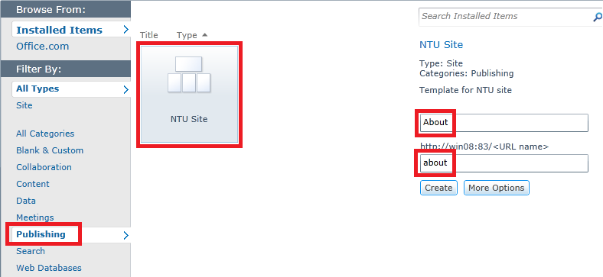

1. Scroll down to the bottom to the ***Navigation Inheritance*** section, change ***Use the top link bar from the parent site*** to **Yes**. Click ***Create*** to create the new sub site.

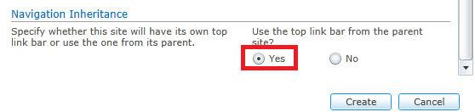

1. By default, Home.aspx page is created when a new site creation.
2. To set the default page layout to use when creating a new page, go to ***Site Settings*** under ***Site Actions***. Click on ***Page layouts and site templates*** under ***Look and Feel***.

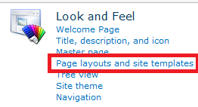

1. Ensure that ***Content Page*** is selected under ***New Page Default Settings*** and then click **OK**.

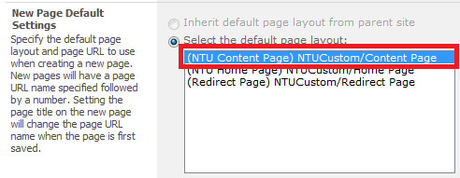

## Create a New Page

### Content Page

1. Click on **Site Actions** > **New Page**.

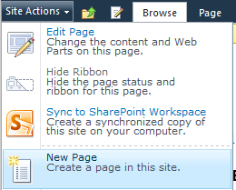

1. Input the ***New page name*** and click **Create**.

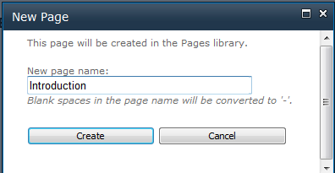

1. The new page will be created and open in Edit Mode.

### Connector Page

The steps to create a connector page are the same as creating a content page. In **Target Page URL** of the page properties, you need to specify the page URL from which the page content should be retrieved. Target page must reside in the same server.

The **Page Content**, **Custom CSS**, and **Custom Javascript** will be retrieved from the target page and displayed on the connector page.

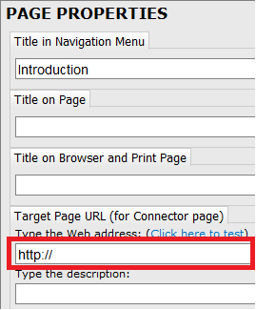

### Redirect Page

1. Go to ***Manage Content and Structure*** under ***Site Actions***.
2. Open the ***Pages*** list/folder in which you want to create the connector page. Click **New** > **Page**.

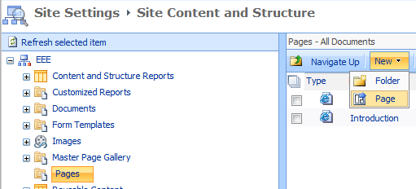

1. Type in the redirect page **Name** and **URL**, and select **Redirect Page** for the Page Layout.

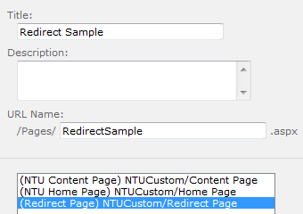

1. Once the page is created, click on the page link to open it. Click on Edit button to enter Edit Mode.

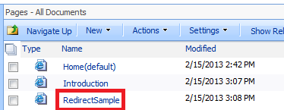

1. In page edit mode, type in the URL to redirect to and save the page.

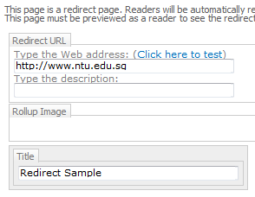

## Setting up Navigation Menu

The top navigation that appears in every page and the side navigation that display sibling pages in the current site can be customized on Site settings.

1. To modify site navigation, go to ***Site Settings*** and click on ***Navigation*** under ***Look and Feel***.

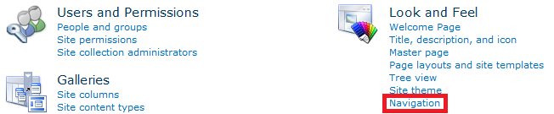

1. On Navigation Settings page, choose ***Sort manually*** under **Sorting**.



1. The top navigation menu uses the menu structure under **Global Navigation** under **Navigation Editing and Sorting**, whereas the side navigation menu uses the **Current Navigation**’s.

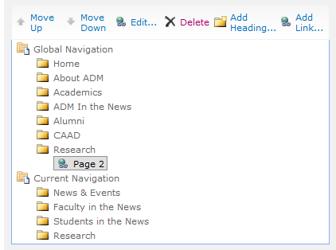

Note: All the subsites should have the same top navigation menu with the 6 items (**About Us**/**Programmes**/**Research**/**News & Events**/**Alumni**/**Contact Us**) as the main site.

Firstly, ensure that there are only 6 subsites visible under **Global Navigation** on **Navigation Settings** of the Main Site:

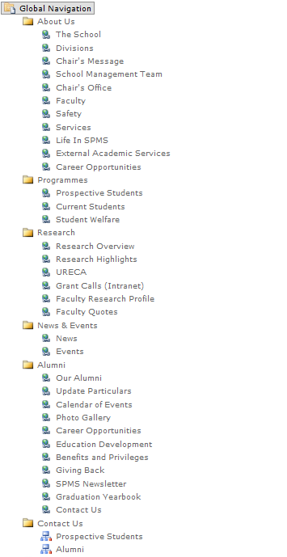

Also, on Navigation Setting page of the subsites, these options should be set as below:

* **Global Navigation**: choose *Display the same navigation items* as parent site and select *Show pages*.
* **Current Navigation**: choose *Display only the navigation items* below the current site and select *Show pages*.
* **Sorting**: choose *Sort manually*.

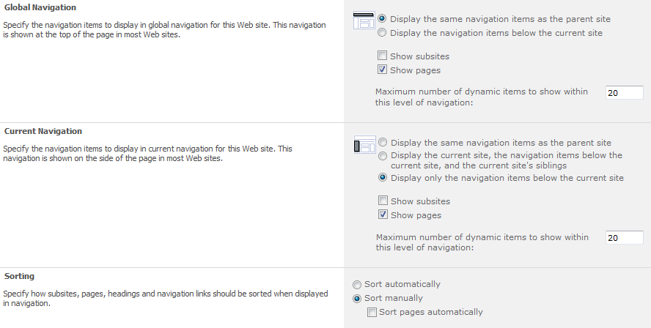

## Rotating Banner(Slider)

Rotating Banner is available in both Home Page and Content Page for showcase the major features and news of the school.

1. By default, the section is hidden. To show and edit this part, go to **Site Actions** -> **Edit Page**, and tick on the ***Slider*** checkbox under **Show Controls** of Page Properties when in page edit mode.

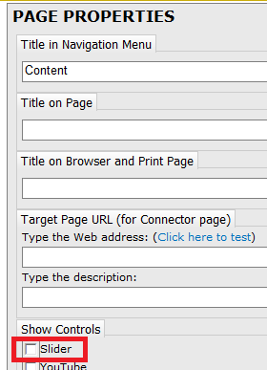

1. Click on ***Page*** -> ***Save and Keep Editing*** on ribbon bar to save the change and continue edit the Rotating Banner.

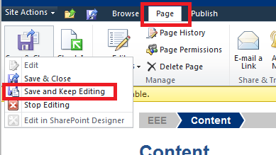

1. The Rotating Banner control will be shown for edit the HTML content.

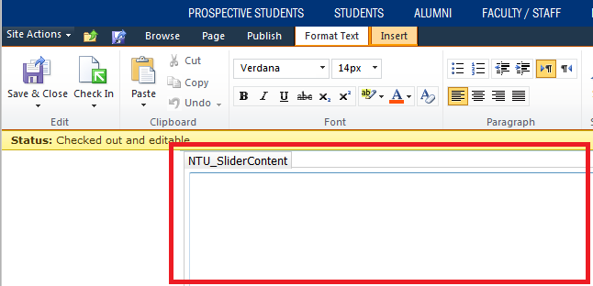

Below is a sample content for the Rotating Banner. The ones in yellow highlighted are the ones need to be changed.

<div id="slider" width="729" height="300">

<!-- Sample for youtube video -->

<div class="youtube" videoId="Pc2hqdYDCJw"></div>

<!-- Sample for hosted video -->

<video id="video1" class="video-js vjs-default-skin" controls

preload="auto" poster="/link-to-video-poster.jpg"

data-setup="{}">

<source src="/link-to-the-video.mp4" type='video/mp4'>

</video>

<!-- Sample for images with links -->

<a href="http://link1">

<IMG src="/link-to-image1.png">

</a>

<a href="http://link2">

<IMG src="/link-to-image2.png">

</a>

<!-- Sample for images without links -->

<IMG src="/link-to-image3.png">

<IMG src="/link-to-image4.png">

</div>

Note:

1. YouTube video id can be retrieved from the query string (parameter **v**) of the following YouTube URL. The ***YouTube*** option under **Show Controls** in Page Properties must be ticked for this to work.

<http://www.youtube.com/watch?v=Pc2hqdYDCJw>

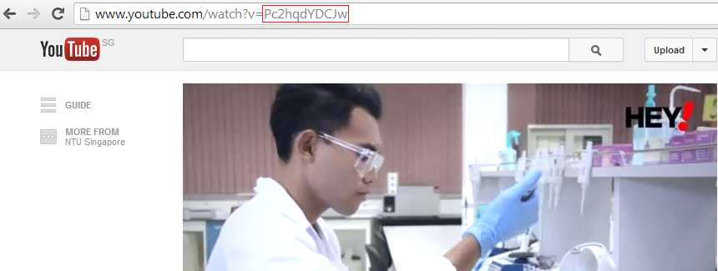

1. For hosted video, it must be in .mp4 format for it to be compatible with mobile browsers. It also requires a poster image, which will be shown when the video is not played yet. The ***VideoJS*** options under **Show Controls** in Page Properties must be ticked for this to work.

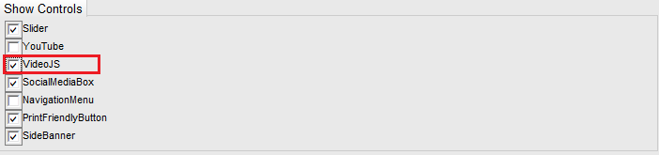

## Social Media Box

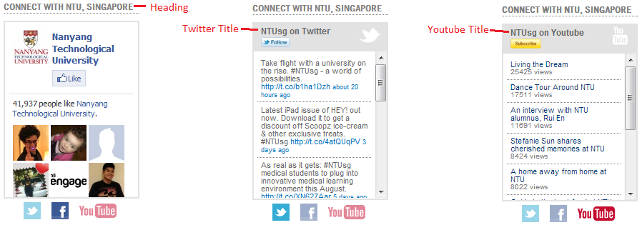

The Social Media Box is catering for showing the feed from NTU Facebook, YouTube and Twitter. To enable it on home page, the ***SocialMediaBox*** option under **Show Controls** in Page Properties must be ticked for this to work.

The username/page for each can be changed through the TwitterUserName, YoutubeUserName, and FacebookPage properties of the Home Page.aspx template by SharePoint Designer.

## Print Friendly Button

This web part provides a link for the print-friendly version of the current page. It opens the current page in a new window and append the query string *print=1*. This will make the page to include print.css and hide the unnecessary things.

To show it on home page, the ***PrintFriendlyButton*** option under **Show Controls** in Page Properties must be ticked for this to work.

## Side Banner

Particularly for Side Banner web part, one needs to upload the images first before adding the web part. Go to ***Manage Content and Structure*** from the ***Site Actions*** link. By default, there is a list called **Side Banner** created in every site and sub-site. This list will be used by the Side Banner web part to get the images to display.

To show it on home page, the ***SideBanner*** option under **Show Controls** in Page Properties must be ticked for this to work.

To add the new item in Side Banner, please follow the steps as below.

1. Click on **New** > **Item** in the Side Banner list under Manage Content and Structure view.

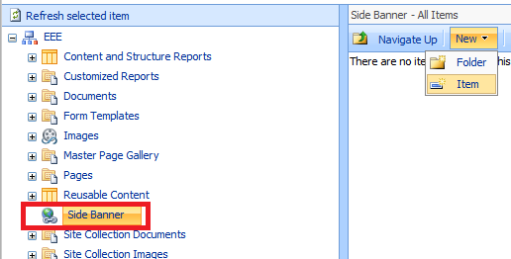

1. Set the item properties as follows:

* External Link : if checked, link will open in a new window.
* Ordering : the order of which item will be shown.
* Show : to show or hide the item in the Side Banner.
* Link : the link to go to when click on the image item.
* Description : text description for the image.
* Attach File : to upload the image. Image maximum width is 190px.

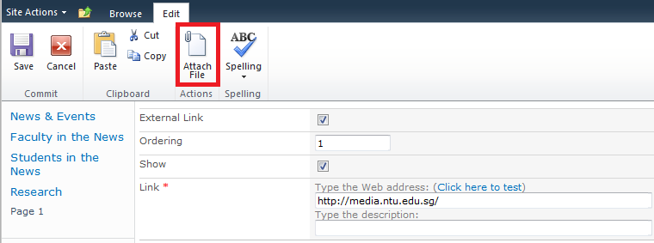

1. Click on **Save** button to save the inputs.

Note: You also can add the Side Banner as a web part on the page, refer to Adding WebParts section.

The images uploaded earlier will be shown in the Side Banner web part. Default height is 388px. You can change the web part’s height through its Height properties in web part properties. Example is the web part below on the right, for which height is set to 450px.

 

## News Webparts

### NewsFilter & NewsList

NewsFilter and NewsList are used to filter and display the school news by year, month and category.

To add and setup the two webparts, please refer to the following steps:

1. Select **Site Actions** -> **Edit Page**.
2. On edit mode, click ***Add a Web Part*** link of one WebPart Zones.
3. Choose **NTU News Webparts** -> **NewsFilter**/**NewsList**, and click **Add**.

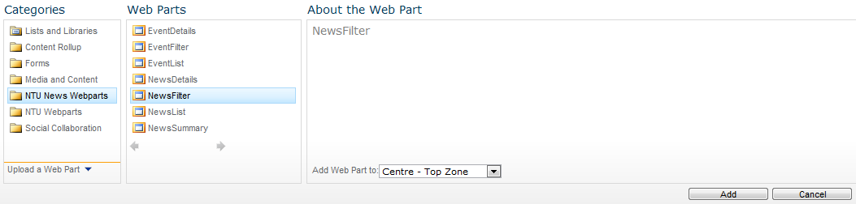

1. Click the arrow icon on the right top of NewsFilter webpart, and navigate to **Connections** -> **Send Row to** -> **NewsList** to select to make the connection with NewsList webpart.

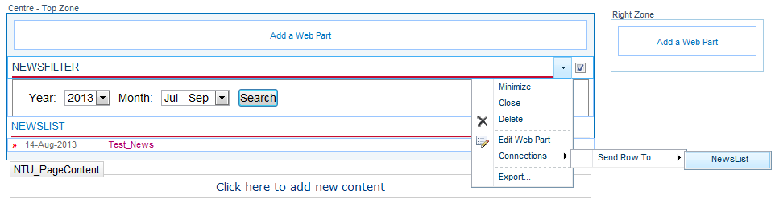

1. On the **NewsFilter** webpart, properties can be set up as follows:

* **Configuration – Appearance** Section
* **Display by period** (Monthly/Quarterly/Yearly): to show the different patterns of the search criteria, the change will take effect after reload the page.
* **CSS class to use for the filter**: the CSS class name is used in this webpart. By default, it is specified by “newsfilter”.
* **Configuration – NewsHub** Section
* **URL of the news site**: to input the resource site URL to get the News items. By default, it is set in web.config file.
* **News category**: to indicate the News category to be shown by filter. If empty, the category dropdown will be displayed.
* **Configuration – Web Service** Section
* **URL of the NewsHub web service**: to specify the web service URL to help retrieving the News Items cross the sites. By default, it is configured in web.config file.

1. Click **OK** to save the updated properties of **NewsFilter** webpart.
2. Select ***Edit Web Part*** of **NewsList** webpart on the right top side to edit its properties as follows:

* **Configuration – Appearance** Section
* **HTML body template**: the whole HTML template of the news listing.
* **HTML template for each category group**: the HTML template of each category group, if the category grouping is enabled.
* **HTML template for each month group**: the HTML template of each month group, if the month grouping is enabled.
* **HTML template for each news item**: the HTML template of each news item.
* **HTML template for no news item**: the HTML template is used, when no news item is retrieved.
* **HTML template to show when error occurred**: the HTML template is used, when any error occurred.
* **Date format for date shown in the news item**: the date format for the displayed date of each news item.
* **Group the news item by** (None/Category): to indicate the grouping pattern. By default, it’s None.
* **Configuration – Miscellaneous** Section
* **URL of the news detail page**: to specify the URL of the news detail page. By default, it’s set from the web.config file.
* **Show archived news items**: to indicate whether to show the archived news items in the list.
* **Open news item with external URL in a new window**: to indicate whether do open the news detail page in a new browser window or current one.
* **Configuration – NewsHub** Section
* **URL of the news site**: to input the resource site URL to get the News items. By default, it is set in web.config file.
* **News category**: to indicate the News category to be shown by filter. By default the category will be passed from filter.
* **Start date** (format: yyyy/mm/dd): to indicate the date to show all the news items, which their period are later than this date.
* **End Date** (format: yyyy/mm/dd): to indicate the date to show all the news items, which their period are earlier than this date.
* **Configuration – Web Service** Section
* **URL of the NewsHub web service**: to specify the web service URL to help retrieving the News Items cross the sites. By default, it is configured in web.config file.

1. Click **OK** to save the updated properties of **NewsList** webpart.
2. Select the **Save & Close** button on ribbon bar of the page to save it.

### NewsDetails

This webpart is used to show the detail content of the news, which to be selected from the News List page.

To add and setup the webpart, please refer to the following steps:

1. Select **Site Actions** -> **Edit Page**.
2. On edit mode, click ***Add a Web Part*** link of one WebPart Zones.
3. Choose **NTU News Webparts** -> **NewsDetails**, and click **Add**.
4. Select Edit Web Part of NewsDetails webpart on the right top side to edit its properties as follows:

* **Configuration – Appearance** Section
* **HTML body template**: the whole HTML template of the news details.
* **HTML template to show when error occurred**: the HTML template is used, when any error occurred.
* **Date format for date shown in the news item**: the date format for the displayed date in news details.
* **Configuration – Miscellaneous** Section
* **Query name for news ID to be pass in**: to indicate the query string name to get the GUID of the news passed in. By default, it’s **news**.
* **Query name for news site url**: to indicate the query string name to get the resource site URL from detail page URL. By default, it’s **site**.
* **Configuration – NewsHub** Section
* **URL of the news site**: to input the resource site URL to get the News items. By default, it is set in web.config file.
* **News ID**: to indicate the News ID to retrieve news content. By default the ID will be passed from URL query string.
* **Configuration – Web Service** Section
* **URL of the NewsHub web service**: to specify the web service URL to help retrieving the News Items cross the sites. By default, it is configured in web.config file.

1. Click **OK** to save the update properties of **NewsDetails** webpart.
2. Select the **Save & Close** button on ribbon bar of the page to save it.

### NewsSummary

This webpart is used to display all the news summary for the school.

To add and setup the webpart, please refer to the following steps:

1. Select **Site Actions** -> **Edit Page**.
2. On edit mode, click ***Add a Web Part*** link of one WebPart Zones.
3. Choose **NTU News Webparts** -> **NewsSummary**, and click **Add**.
4. Select Edit Web Part of NewsSummary webpart on the right top side to edit its properties as follows:

* **Configuration – Appearance** Section
* **HTML body template**: the whole HTML template of the news summary list.
* **HTML template for each news item**: the HTML template of each news item.
* **HTML template for no news item**: the HTML template is used, when no news item is retrieved.
* **HTML template for show when error occurred**: the HTML template is used, when any error occurred.
* **Date format for date shown in the news item**: the date format for the displayed date of each news item.
* **Configuration – Miscellaneous** Section
* **Number of news item to show** (0 = unlimited): to indicate the max number of the news items should be shown in summary list. By default, it’s 5.
* **URL of the news listing page**: to specify the URL of the news listing page. If empty, the hyperlink (More Items) will be disabled.
* **URL of the news detail page**: to specify the URL of the news detail page. By default, it’s set from the web.config file.
* **Open news item with external URL in a new window**: to indicate whether do open the news detail page in a new browser window or current one.
* **Configuration – NewsHub** Section
* **URL of the news site**: to input the resource site URL to get the News items. By default, it is set in web.config file.
* **News category**: to indicate the News category to be shown by filter. If empty, all the categories will be shown
* **Configuration – Web Service** Section
* **URL of the NewsHub web service**: to specify the web service URL to help retrieving the News Items cross the sites. By default, it is configured in web.config file.

## Event Webparts

### Event Filter & Event List

Event Filter & Event List web parts are used to filter and display the events of the school.

To add and setup the two webparts, please refert to the following steps:

1. Select **Site Actions** -> **Edit Page**.
2. On edit mode, click ***Add a Web Part*** link of one WebPart Zones.
3. Choose **NTU News Webparts** -> **EventFilter**/**EventList**, and click **Add**.

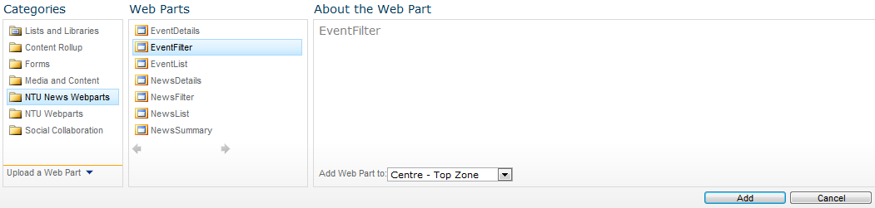

1. Click the arrow icon on the right top of EventFilter webpart, and navigate to **Connections** -> **Send Row to** -> **EventList** to select to make the connection with EventList webpart.

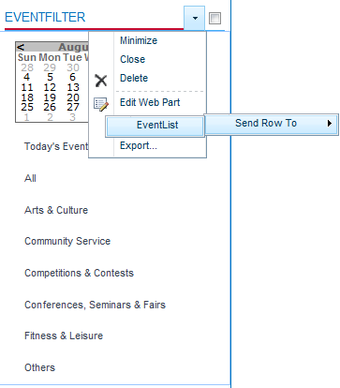

1. On the **EventFilter** webpart, properties can be setup as follows:

* **Configuration – Appearance** Section
* **Show Calendar**: to indicate whether the calendar should be shown on the event filter.
* **Show Today Events Link**: to indicate whether the Today’s Events link should be shown on the event filter.
* **Show Event Categories Selections**: to indicate whether the Categories selection links should be shown on the event filter.
* **CSS class to use for the filter**: the CSS class name is used in this webpart. By default, it is specified by “eventfilter”.
* **Configuration – NewsHub** Section
* **URL of the event site**: to input the resource site URL to get the Event items. By default, it is set in web.config file.
* **Configuration – Web Service** Section
* **URL of the NewsHub web service**: to specify the web service URL to help retrieving the Event Items cross the sites. By default, it is configured in web.config file.

1. Click **OK** to save the updated properties of **EventFilter** webpart.
2. Select ***Edit Web Part*** of **EventList** webpart on the right top side to edit its properties as follows:

* **Configuration – Appearance** Section
* **HTML body template**: the whole HTML template of the event listing.
* **HTML template for each event item**: the HTML template of each event item.
* **HTML template for no event item**: the HTML template is used, when no event item is retrieved.
* **HTML template to show when error occurred**: the HTML template is used, when any error occurred.
* **Title to be shown**: to specify the list title to be shown after each search. The value from filter will be overwritten this field.
* **Date format for date shown in the event**: the date format for the displayed date of each event item.
* **Time format for date shown in the event**: the time format for the displayed time of each event item.
* **Configuration – Miscellaneous** Section
* **List of literals to be consider as empty string** (delimited by ‘,’): if the content string value is in this list, it will be considered as empty string.
* **Number of characters limit for event summary**: to indicate the number of characters to limit the event summary.
* **URL of the event detail page**: to specify the URL of the event detail page. By default, it’s set from the web.config file.
* **Show archived event**: to indicate whether to show the archived event items in the list.
* **Configuration – NewsHub** Section
* **URL of the event site**: to input the resource site URL to get the Event items. By default, it is set in web.config file.
* **Event category**: to indicate the Event category to be shown by filter. By default the category will be passed from filter.
* **Event date** (format: yyyy/mm/dd): to indicate the date to show all the news items, which their period includes the date.
* **Configuration – Web Service** Section
* **URL of the NewsHub web service**: to specify the web service URL to help retrieving the Event Items cross the sites. By default, it is configured in web.config file.

1. Click **OK** to save the updated properties of **EventList** webpart.
2. Select the **Save & Close** button on ribbon bar of the page to save it.

### Event Details

This webpart is used to show the detail content of the event, which to be selected from the Event List page.

To add and setup the webpart, please refer to the following steps:

1. Select **Site Actions** -> **Edit Page**.
2. On edit mode, click ***Add a Web Part*** link of one WebPart Zones.
3. Choose **NTU News Webparts** -> **EventDetails**, and click **Add**.
4. Select Edit Web Part of EventDetails webpart on the right top side to edit its properties as follows:

* **Configuration – Appearance** Section
* **HTML body template**: the whole HTML template of the event details.
* **HTML template to show when error occurred**: the HTML template is used, when any error occurred.
* **HTML template for registration link**: the HTML template of the event registration link.
* **Date format for date shown in the event**: the date format for the displayed date in event details.
* **Time format for date shown in the event**: the time format for the displayed date in event details.
* **Configuration – Miscellaneous** Section
* **Query name for event ID to be pass in**: to indicate the query string name to get the GUID of the event passed in. By default, it’s **event**.
* **Query name for NewsHub site url**: to indicate the query string name to get the resource site URL from detail page URL. By default, it’s **site**.
* **Configuration – NewsHub** Section
* **URL of the event site**: to input the resource site URL to get the Event items. By default, it is set in web.config file.
* **Event ID**: to indicate the Event ID to retrieve event content. By default the ID will be passed from URL query string.
* **Configuration – Web Service** Section
* **URL of the NewsHub web service**: to specify the web service URL to help retrieving the Event Items cross the sites. By default, it is configured in web.config file.

1. Click **OK** to save the update properties of **EventDetails** webpart.
2. Select the **Save & Close** button on ribbon bar of the page to save it.